Model Solar Language Brief
Every Wisconsin community should have zoning language that addresses solar energy systems. Wisconsin has several laws that protect a resident's right to install and operate a solar energy system. These state laws cover zoning restrictions by local governments, private land use restrictions, and system owner rights to unobstructed access to resources. Each municipality can model its own zoning language after the state laws. Without solar energy zoning ordinances, other existing local zoning ordinances could conflict with the Wisconsin state laws, and could create difficulties for home or business owners to invest in solar energy.
Solar energy zoning ordinances can improve communities and aid city staff when processing permits or doing field inspections. The City of Milwaukee, through the City’s solar program Milwaukee Shines, has implemented solar zoning. Milwaukee’s solar energy zoning was modeled after the Wisconsin Statute §66.0401, so it satisfies the state requirements, but also modifies general requirements to fit to the Milwaukee community.
The model zoning language from the City of Milwaukee can be found below. Municipalities are encouraged to add this language to existing zoning ordinances to clarify solar access rights for residents and to help staff and elected officials encourage properly sited solar installations.
Questions? If you would like to add solar zoning to your community, but still have questions, please contact Milwaukee Shines, the City of Milwaukee Solar Program:

Milwaukee Shines
200 E Wells Street
City Hall, Room 603
solar@milwaukee.gov
414-286-5593
wwww.MilwaukeeShines.com

City of Milwaukee Model Solar Zoning Language
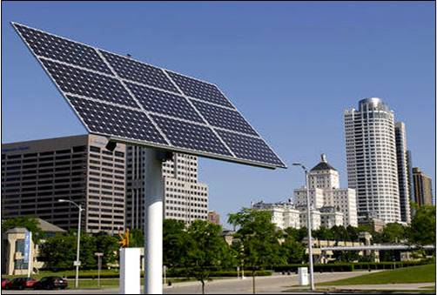
Definitions: The City of Milwaukee used the definitions provided in the Wisconsin state statute to clarify what equipment is used as part of a solar energy system and for what land uses. Definitions included in the City of Milwaukee solar energy zoning were: solar collector, solar array, and solar farm.
Solar Collector: A device, structure, or part of device, the substantial purpose of which is to transform solar energy into thermal, mechanical, chemical, or electrical energy.
Solar Electric Ground-Mounted Solar Array at Discovery World near Lake Michigan in Milwaukee, Wisconsin
Solar Array: An accessory system or device that is roof-mounted or ground-mounted with poles or racks used to collect radiant energy directly from the sun for use in a solar collector’s energy transformation process.

Solar Farm: An array of multiple solar collectors on ground-mounted racks or poles that transmit solar energy and is the primary land use for the parcel on which it is located.

Solar Access Rights: The authority to restrict systems is limited by Wisconsin state law. This is noted in the state statute and should be replicated in municipal zoning. Milwaukee zoning meets the minimum requirements of the state statute so residents have full access to install solar throughout the city. In addition, this language reflecting the state statute helps the Milwaukee Board of Zoning Appeals if issues regarding solar access rights come before the committee. For further details, on the wording of solar access rights read the Wisconsin State Statute §66.0401.

General Requirements: When it comes to land use regulations, Milwaukee did not see a need for many requirements, as most urban installations of solar are typically rooftop installations. However, general setback restrictions may need to be addressed on solar ground-mounted systems and solar farms for land use purposes. The purpose of setting these minimal requirements is to provide satisfaction for neighbors while ensuring that the restrictions do not increase the price or decrease the efficiency of a property owner’s solar energy system. The City of Milwaukee looked to existing structures and uses to set general requirements:
Ground-Mounted Solar Energy Systems Setback Requirements:
  - If less than 20 feet in height: setback must comply with 1.5 feet from all property lines.
  - If greater than 20 feet in height the ground-mounted solar energy system must comply with setback regulations for a principal building structure.
In addition, the City of Milwaukee set general requirements for signage in regards to solar energy systems. Only one sign is allowed per solar array. The display area must be less than six square feet in size and must be either for acknowledgement or educational purposes.

Permitted Uses: No resident or business owner can be restricted in installing solar due to Wisconsin State Statute §66.0401 unless the restriction satisfies on of the following conditions:
- Serves to preserve or protect the public health or safety.
- Does not significantly increase the cost of the system or significantly decrease its efficiency.
- Allows for an alternative system of comparable cost and efficiency.

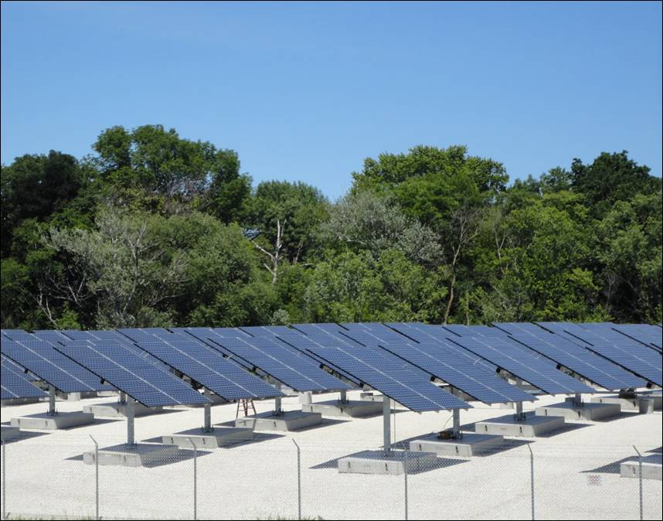
Solar Farms: With solar energy becoming a mainstream source for energy for homeowners and business owners, solar farms are becoming more prevalent in cities across the United States. Cities need to prepare with solar farm zoning. Below is the City of Milwaukee’s definition of a solar farm:
Solar Farm: An array of multiple solar collectors on ground-mounted racks or poles that transmit solar energy and is the primary land use for the parcel on which it is located.

Since solar farms are the primary use for a parcel of land, setbacks were determined based on existing setback requirements for principal structures that functioned as the primary use as determined by Milwaukee’s current zoning districts. To maintain the character of certain neighborhoods and districts, the City of Milwaukee applied a special use for solar farms in some zoning districts. If a solar farm is proposed in a special district it goes before the City of Milwaukee Board of Zoning Appeals to address issues related to solar in that zoning district as applicable to the community. Below is the table that outlines permitted uses for solar farms in the City of Milwaukee:
Solar Farm - MATC Blue Hole Project Located on Capitol Drive in Milwaukee, Wisconsin
Solar Farm Setback Requirements:
  - Cannot exceed setback requirements for principal structures as primary use as determined by zoning district.
Zoning District | Use
Residential | Permitted
Commercial | Special
Commercial Services | Permitted
Downtown | Special
Industrial | Permitted
Special (Schools, parks) | Permitted
Lakefront Overlay | Special

